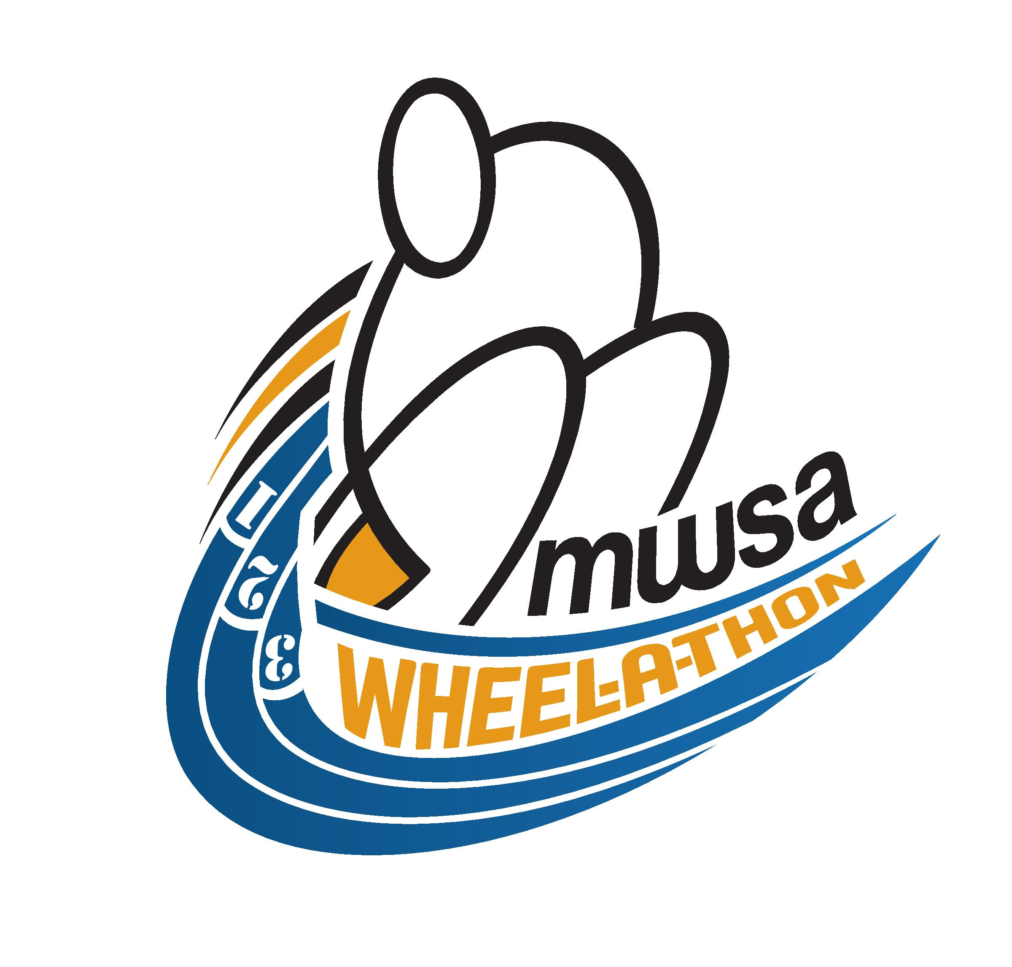
Saturday, September 20, 2014, 9:00 am at Grant Park High School – Track & Field
In support of Manitoba Wheelchair Sport Association
Dear Potential Pledger,
I am participating in the 2014 Wheel-a-thon in support of the Manitoba Wheelchair Sport Association and in support of wheelchair sports in Manitoba. Your pledge will go towards my team, , as we compete in a 4x400 meter relay race.
Cheques can be made payable to Manitoba Wheelchair Sport Association. All contributions over $20 will receive a tax receipt.
Thank you for your support!

Name | Address | Postal Code | Amount Pledged ($) | Tax Receipt?

