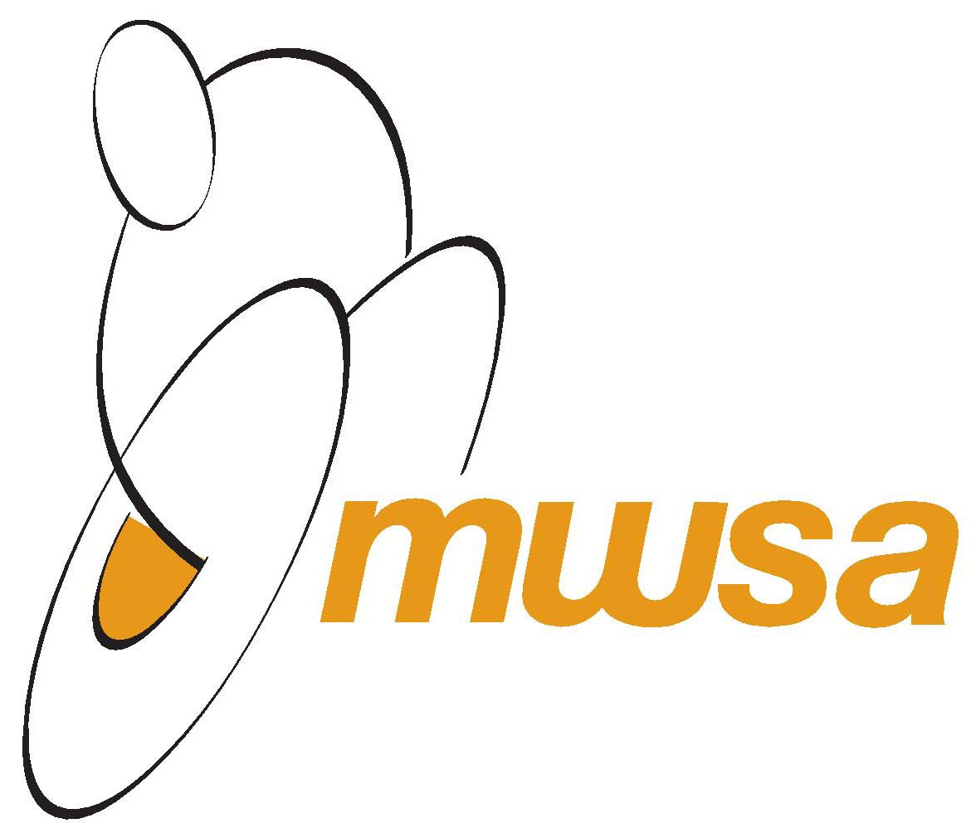
APPLICATION FOR MEMBERSHIP
September 1 – August 31

MEMBER INFORMATION

Name: Address:

City: Province: Postal Code:

Telephone (H) ( ) Telephone (Alt): ( )

E-Mail Address: Date of Birth: / /

Disability: Gender:

MEMBERSHIP TYPE
[ ] Adult ($15) [ ] Youth – 17 and under ($10) [ ] Family ($25)

Fee enclosed:$ .
Please make cheques payable to Manitoba Wheelchair Sport Association

SPORT INFORMATION
What sport(s) are you interested in?

[ ] Wheelchair Basketball [ ] Wheelchair Rugby [ ] Wheelchair Tennis [ ] Other

ACCEPTANCE OF MEMBERSHIP TERMS

- I realize that, with this Membership, I may be subject to unannounced drug testing as provided for by Wheelchair Basketball Canada’s and Canadian Wheelchair Sport Associations’ agreement with the Canadian Centre for Ethics in Sport.
- In consideration of my acceptance as a member of MWSA, I hereby agree to follow all policies, procedures, rules and regulations set out by MWSA.
- I understand that MWSA retains personal information about me in their files. I accept the use of my personal information for the purposes described in accordance with MWSA’s Privacy Policy, which is available by contacting the MWSA office.

I agree to the above terms of Membership, upon my admission to Manitoba Wheelchair Sport Association as a member.

Signature (Guardian if under 18) Date:

Forms and payment can be submitted to:
Manitoba Wheelchair Sport Association, 430 – 145 Pacific Ave, Winnipeg, MB, R3B 2Z6
Ph: 204-925-5790 – Fax: 204-925-5792 – mwsa@sportmanitoba.ca

