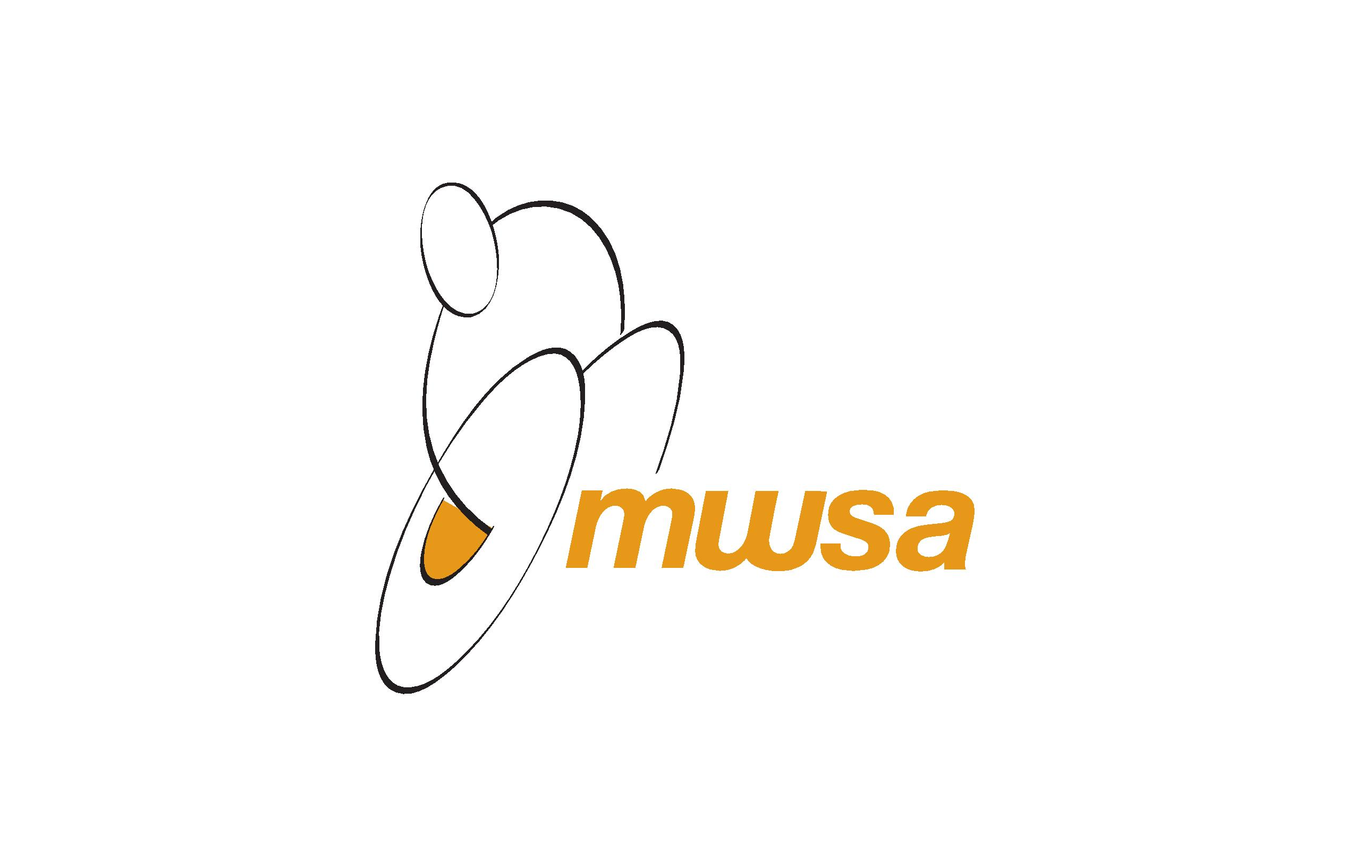
MINI- PARALYMPIC CAMP – August 18 – 22, 2014
Registration Form
Name:
Birth date (required):
Mailing Address:

Phone Number – (H): (W): (C):
Email:
Nature of disability (if applicable):

The cost of the week-long camp is $175.00 per child and can be paid by cheque to Manitoba Wheelchair Sport Association. You may also choose to register your child/children for a specific day(s), and that cost is $40.00 per day per child.
Please circle: Full week, August 18, August 19, August 20, August 21, August 22.
You must also complete, and include with payment the attached medical form.
For insurance purposes, participants are required to be members of Manitoba Wheelchair Sport Association. Form is attached and it, along with $5.00 fee can be submitted with camp registration form.
Upon receipt of all forms, campers will receive a confirmation letter along with a list of items to bring to camp.
Registration deadline is Tuesday August 5, 2014.
Mailing address: Manitoba Wheelchair Sport Association, 145 Pacific Avenue, Winnipeg MB, R3B 2Z6.
If you have any questions or concerns, please do not hesitate to contact us at 204-925-5790, mwsa@sportmanitoba.ca, or mwsa.proco@sportmanitoba.ca.
Thank you to MTS Allstream for supporting the Mini-Camp program through their Future First Grant initiative.

