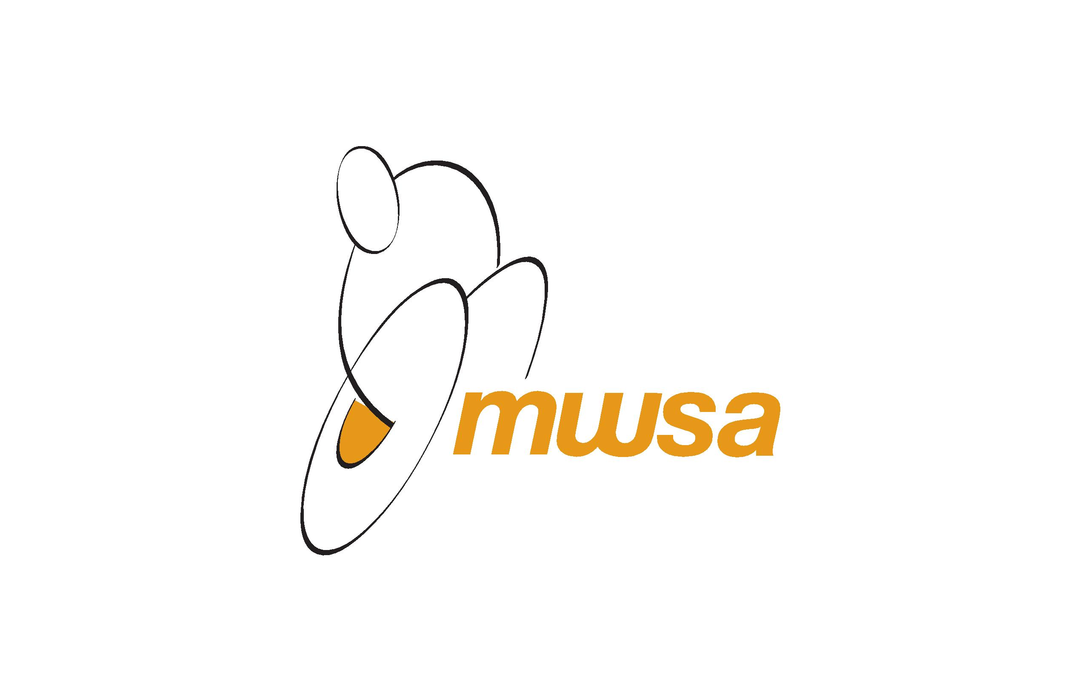
Mini-Paralympic Camp August 18-22, 2014
SCHEDULE
August 18 9:00 am - drop off at Youth For Christ, 333 King Street.
Wheelchair Fencing and Sitting Volleyball.
Lunch, transfer via Dignity Taxi to Norwood Community Club.
1:30 pm – 3:30 pm Wheelchair Tennis at Norwood Tennis.
4:00 pm –pick up from Norwood Community Club.

August 19 9:00 am - drop off at Youth For Christ, 333 King Street.
Wheelchair Fencing and Wheelchair Basketball.
Lunch.
Wheelchair Dance and Wheelchair Rugby.
4:00 pm – pick-up from Youth For Christ, 333 King Street.

August 20 9:00 am - drop off at Fort Whyte Alive.
Morning: Able Sailing.
Lunch & Fort Whyte Farms
Afternoon: Para-Paddling.
3:30 pm - pick-up from Fort Whyte Alive.

August 21 9:00 am - drop off at Heartland Archery, 10-K Keenleyside Street.
Para-Archery.
11:30 am - transfer via Dignity Taxi to East End Arena, Lunch.
2:00 pm – 3:30 pm: Sledge Hockey.
4:00 pm - pick-up from East End Arena, 517 Pandora Ave East.

August 22 9:00 am – drop off at Gordon Bell High School (field on Maryland Ave).
Wheelchair Baseball.
11:30 am - transfer via Dignity Taxi to Sport For Life, Lunch.
1:30 pm – 3:30 pm – ART City at Sport For Life.
4:00 pm – pick-up from Sport For Life, 145 Pacific Avenue.

Snacks and bottled water will be provided in the morning and afternoon. Lunch included daily.

Thank you to MTS Allstream for supporting the Mini-Camp program through their Future First Grant initiative.

