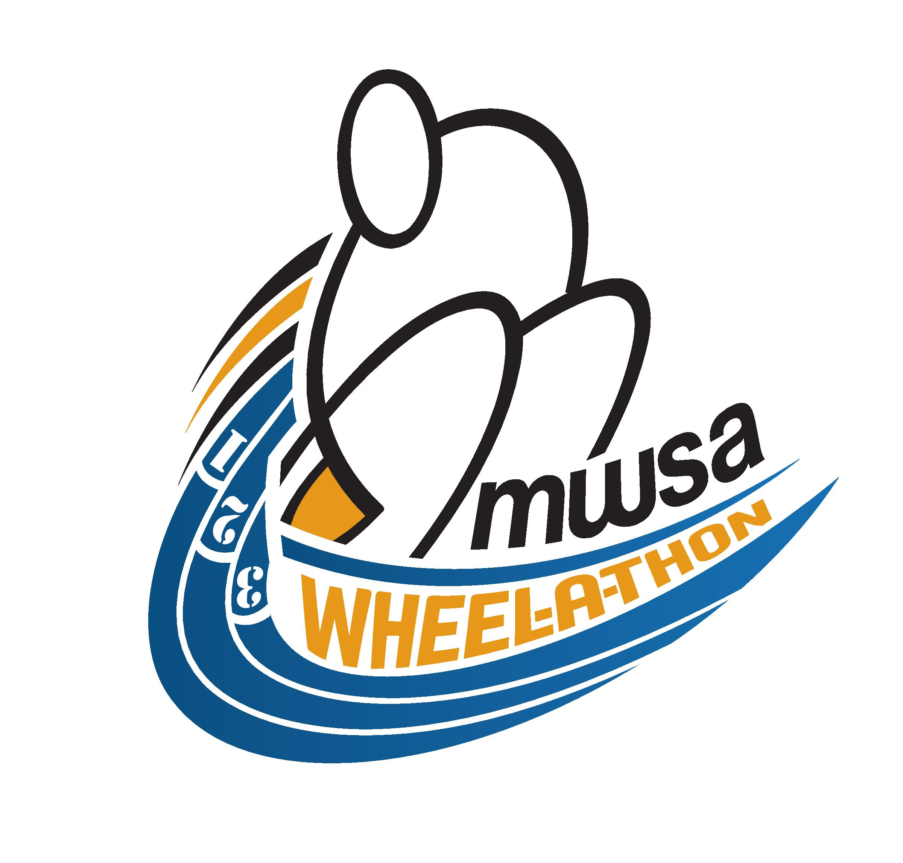

SATURDAY SEPT. 20, 2014 at 9:00 AM - GRANT PARK HIGH SCHOOL TRACK

THE 2014 MANITOBA WHEELCHAIR SPORT ASSOCIATION
WHEEL-A-THON IS SUPPORTED BY:

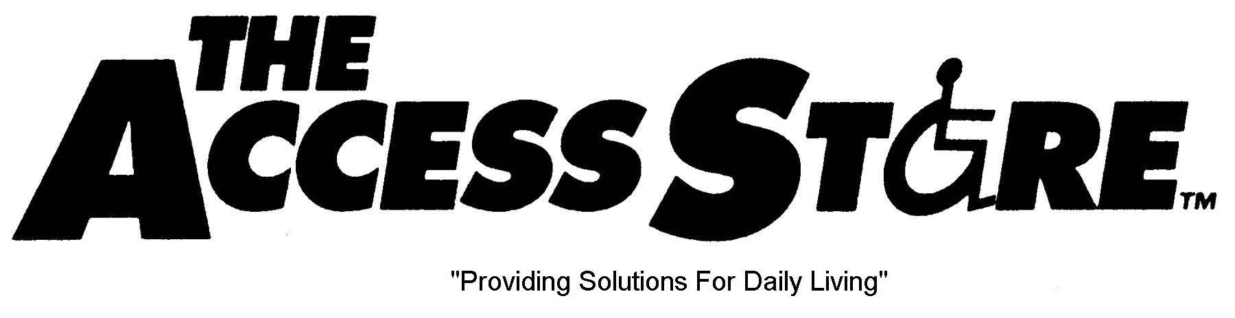

Presented By:

MANITOBA WHEELCHAIR SPORT ASSOCIATION
2014 WHEEL-A-THON FUNDRAISER
SEPTEMBER 20, 2014, 9:00 AM
GRANT PARK HIGH SCHOOL PAVED OUTDOOR TRACK

In support of: Manitoba Wheelchair Sport Association
Non-Profit, Charitable Organization
“Developing motivation, inspiration, confidence, and independence through wheelchair sport and physical activity.”

Event Details: Participants will compete in a 4x400 meter relay race in teams of four (4). Teams will be scheduled into heats.

Food and drinks will be available on-site during the event.

Registration Fee: $50 per team

Registration Deadline: September 10, 2014

Pledges: Teams are encouraged to collect a minimum of $200 in pledges/donations. Contributions over $20 are eligible for a tax receipt.

Contact Information: Please submit registrations, pledges/donations, and any inquiries to:

Angela Lloyd, Executive Director
Manitoba Wheelchair Sport Association
145 Pacific Avenue, Winnipeg MB, R3B 2Z6
204-925-5790
mwsa@sportmanitoba.ca
www.mwsa.ca

Team Information:

#1
Name (Captain):
Company (If Applicable):
Address: |  |  |  | City: |  | Postal:
Phone Number: (H) |  |  |  | (Alt):
Email: |  |  |  |  |  | T-Shirt Size:

#2
Name:
Company (If Applicable):
Address: |  |  |  | City: |  | Postal:
Phone Number: (H) |  |  |  | (Alt):
Email: |  |  |  |  |  | T-Shirt Size:

#3
Name :
Company (If Applicable):
Address: |  |  |  | City: |  | Postal:
Phone Number: (H) |  |  |  | (Alt):
Email: |  |  |  |  |  | T-Shirt Size:

#4
Name:
Company (If Applicable):
Address: |  |  |  | City: |  | Postal:
Phone Number: (H) |  |  |  | (Alt):
Email: |  |  |  |  |  | T-Shirt Size:

Participation Waiver

This form must be signed by each participant of a team.

As a participant, I understand that racing a wheelchair is a potentially hazardous activity. I should not enter and wheel unless I am medically able. I hereby certify that I am in good health and assume all risks associated with participating in the 2014 Wheel-a-thon including, but not limited to: falls, contact with other participants, the effects of weather, including high heat and/or humidity. Having read this waiver and knowing these facts and in consideration of accepting my registration in this event, I, for myself and anyone entitled to act on my behalf, waive and release the Manitoba Wheelchair Sport Association Inc, its officers, directors, agents, volunteers and employees, the Winnipeg School Division, all sponsors, their representatives and successors from all claims or liabilities of any kind arising out of my participation in this event even though that liability may arise out of negligence or carelessness on the part of the persons named in this waiver.

I grant permission to all of the foregoing to use any photographs, motion pictures, recordings or any other record of this event for any legitimate purpose.

Signature (Parent or Guardian if under 18) Participant # under 18

/ /
Signature – Participant #1 Date:

/ /
Signature – Participant #2 Date:

/ /
Signature – Participant #3 Date:

/ /
Signature – Participant #4 Date:

