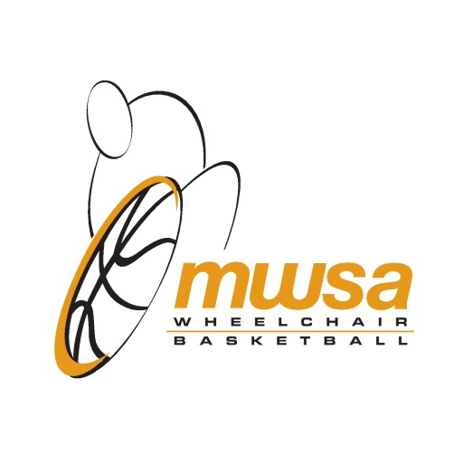

WHEELCHAIR BASKETBALL CLINIC – October 4 and 5, 2014
MWSA has organized a Wheelchair Basketball Clinic for new athletes to the sport or returning athletes wanting to hone their skills. Clinic is open to all ages, skill levels, and abilities.
Saturday October 4, 2014 – Sport For Life, 145 Pacific Avenue, Winnipeg:
9:00 am – 10:00 am – Sport Nutrition.
10:15 am – 11:00 am – Sport Physiology.
11:15 am – 12:15 pm – Sport Psychology.
12:30 pm – Lunch.
Sunday October 5, 2014 – La Salle Community Centre, La Salle, MB:
9:30 am – 4:30 pm – Skills & Drills, Game Playing, Equipment Maintenance.
Clinic cost - $30.00 for both days or $15.00 per day, must be MWSA member to attend. Lunch will be included on Saturday October 4, 2014 only.
Registration deadline – Thursday October 2, 2014. Contact MWSA at 204 925-5790 or mwsa@sportmanitoba.ca to register or if you have any questions.

